**RP-IPRC MUSANZE**

26April2022

**Project tittle:TURNING ON BUZZER USING MQ-3 SMOKE SENSOR**

**Prepared by:**

**DUKUZIMANA Alexis Reg: 19RP08929**

**HABIMANA Felix Reg: 19RP08327**

1. **ABSTRACT**

Nowadays smoking is common threat as well as people's life. we cannot stop people from smoking but we can avoid these accident by checking whether there is anyone smoking around in any place which is not allowed smoking take place in order to avoid and control these accident which may occurs we supposed to install these small device namely: **MQ3 SMOKE SENSOR/ Smoke detector** which will help us to know whether there is smoking around.

In generally, this project comes as a solution to show us anyone who is smoking in a wrong place, Nowadays we face with more problem of fire accident occurs in society at high level same of those accident caused by people who smoking in place which is not allowable to smoke in ,that way we bring this **MQ3 smoke sensor** because it may help us in protection and controlling our building because in case there is anyone who is smoking around or when the smoke reaches in a certain place, it will make sound a buzzer and a L ED will turn on as notification that indicate that there is smoking near by the building which is not allowable for smoking this will help us to control all accident which can occurs from fire not only this sensor also can help us in health sector to detect anyone who is smoking for example (tobacco) because to smoke in public is not good because it can Cause many diseases related with respiratory system so by using this smoke sensor also can help in monitoring the distribution of respiratory diseases in society

2. **PROBLEM STATEMENT**

In this day smoking is common threat as well as other people’s life. we cannot stop people from smoking for example(tobacco) smoking can Cause fire accident and same of respiratory system diseases we already knows that for example smoke which occurs from tobacco is very harmful to human life but we can avoid these problems caused by those different smokes by installing a small device namely**: MQ-3 smoke sensor** or **smoke detector** by using Arduino uno in different places to check whether there is no smoke around and in case there is smoke around our building sensor can detect it and send signal to the user the signal can be transmitted by buzzer through sound then operators come and check what kind off problem related with smoke is there is in such case this sensor may help us to decrease that accident of fire and also respiratory system diseases because no person can smoking in public place when there is that MQ3 smoke sensor.

1. **Block diagram and description**

BUZZER

ARDUINO UNO

MQ3 SMOKE SENSOR

LED

**Description**

**1. Arduino uno**: is an open - source microcontroller board based on the microchip ATmega328P microcontroller. This board is equipped with sets of digital and analog input output pins.

**2. Smoke sensor**: it is an alcohol indicator that can be used to detect from smoking, gas and in different beverage.

**3. Buzzer**: it is an electromechanical device used give a signal inform of sound.

**4.Lamp**: it is used for lighting

1. **Circuit diagram drown in fritzing**

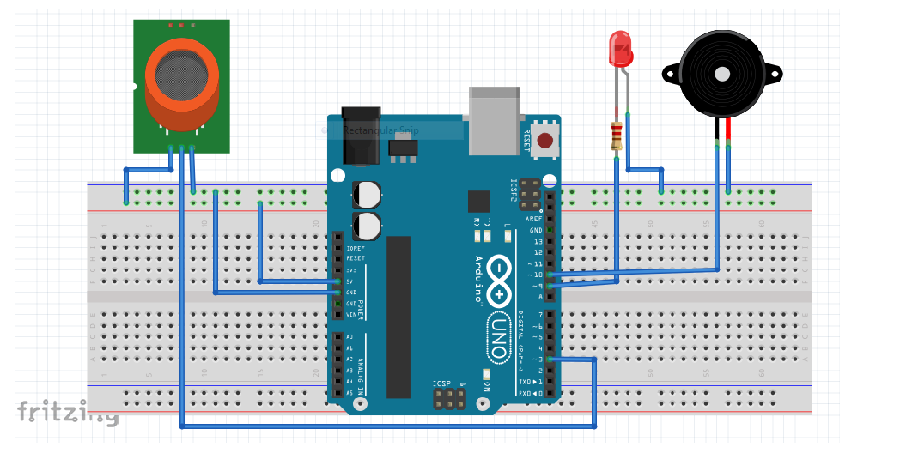

1. **Simulation in PROTEUS**

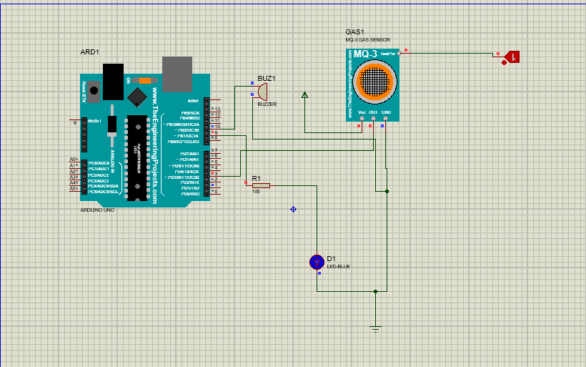

1. **SOURCE CODE IN ARDUINO IDE**

